Bài tập thực hành 04

Lập trình PHP nâng cao

Mục tiêu cần đạt:
Sau buổi các bạn cần nắm thao tác sử dụng PHP nâng cao
- Hiểu và biết cách dùng Cookies và Session
- Tạo form đăng nhập và dùng cookies, session để quản lý các đăng nhập, thực hiện chức năng log out (thoát) khỏi hệ thống
- Biết về SQL Injection.
- Upload file, lưu thông tin về tập tin trong CSDL
- Đọc, và xử lý nội dung trong tập tin

Các bạn đọc và thực hiện viết code như hướng dẫn để làm quen, sau đó đọc trả lời các Yêu cầu ở dưới bài hướng dẫn để thực hiện yêu cầu bài thực hành.

Gợi ý Tham khảo:
- https://www.w3schools.com/php/
- và các nguồn khác mà sinh viên tìm được

Tạo Cookies
Cookies và Session hỗ trợ chúng ta quản lý các phiên đăng nhập/đăng nhập, hoạt động của người dùng trên các website
Tạo tập tin sử dụng khởi tạo cookies ck.php sau:

ck.php

<!DOCTYPE html>
<?php
$cookie_name = "user";
$cookie_value = "Nguyen Thanh Hai";
setcookie($cookie_name, $cookie_value, time() + (86400 / 24), "/"); // 86400 = 24*3600 = 1 day
?>
<html>
<body>

<?php
if(!isset($_COOKIE[$cookie_name])) {
echo "Cookie named '" . $cookie_name . "' chua duoc thiet lap, ban vui long bam f5 de thiet lap cookie!";
} else {
echo "Cookie '" . $cookie_name . "' da duoc thiet lap!<br>";
echo "Gia tri la: " . $_COOKIE[$cookie_name];
}
?>

<p><strong>Note:</strong> You might have to reload the page to see the value of the cookie.</p>

</body>
</html>

Tạo 1 trang đăng ký người dùng với mật khẩu được mã hóa
Tạo csdl qlbanhang, với bảng customers đầu tiên như sau:

CREATE TABLE `customers` (
`id` int(6) UNSIGNED NOT NULL,
`fullname` varchar(50) CHARACTER SET latin1 NOT NULL,
`email` varchar(50) CHARACTER SET latin1 DEFAULT NULL,
`Birthday` date DEFAULT NULL,
`reg_date` timestamp NOT NULL DEFAULT current_timestamp() ON UPDATE current_timestamp(),
`password` varchar(50) NOT NULL
) ENGINE=InnoDB DEFAULT CHARSET=utf8;

Tạo formnhap.php

formnhap.php
<!DOCTYPE HTML>
<html>
<body>

<form action="luu.php" method="post">
Name: <input type="text" name="name"><br>
E-mail: <input type="text" name="email"><br>
Birthday: <input type="date" name="birth"><br>
Password: <input type="password" name="pass"><br>

<input type="submit">
</form>

</body>
</html>
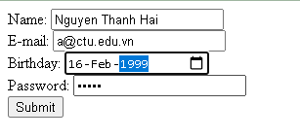

Và luu.php, chú ý lúc này chúng ta sẽ mã hóa mật khẩu với giải thuật md5 để bảo mật mật khẩu:

luu.php
<?php
$servername = "localhost";
$username = "root";
$password = "";
$dbname = "qlbanhang";

// Create connection
$conn = new mysqli($servername, $username, $password, $dbname);
// Check connection
if ($conn->connect_error) {
die("Connection failed: " . $conn->connect_error);
}

$date = date_create($_POST["birth"]);

$sql = "INSERT INTO customers (fullname, email, birthday, password)
VALUES ('".$_POST["name"] ."', '".$_POST["email"] ."', '".$date ->format('Y-m-d') ."','".md5($_POST["pass"])."' )";

if ($conn->query($sql) == TRUE) {
echo "Them sinh vien thanh cong";
} else {
echo "Error: " . $sql . "<br>" . $conn->error;
}

$conn->close();
?>

Sau khi chúng ta nhập xong mật khẩu với 12345 nhưng khi quan sát trong CSDL ta sẽ thấy mật khẩu đã được mã hóa ra chuỗi 827ccb0eea8a706c4c34a16891f84e7b:
Trong trường hợp chúng ta muốn dùng email là username để đăng nhập ta nên đảm bảo 2 student không có email trùng nhau. Để đảm bảo điều này ta có thể chọn email là unique key (vì ta đã chọn id la primary key, và 1 bảng không thể có 2 khóa chính)

ALTER TABLE `customers` ADD UNIQUE( `email`);

Tạo form đăng nhập
Sau khi tạo người dùng xong, ta có thể chạy form đăng nhập với username là email và password lấy từ CSDL

Login.php
<!DOCTYPE HTML>
<html>
<body>

<form action="log.php" method="post">
Username: <input type="text" name="email"><br>
Password: <input type="password" name="pass"><br>

<input type="submit">
</form>

</body>
</html>

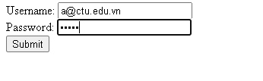

Log.php
<?php
$servername = "localhost";
$username = "root";
$password = "";
$dbname = "qlbanhang";

// Create connection
$conn = new mysqli($servername, $username, $password, $dbname);
// Check connection
if ($conn->connect_error) {
die("Connection failed: " . $conn->connect_error);
}

$sql = "select fullname, email from customers where email = '".$_POST["email"]."' and password = '".md5($_POST["pass"])."'";

$result = $conn->query($sql);

if ($result->num_rows > 0) {
echo "Dang nhap thanh cong <br>";
$row = $result->fetch_assoc();
echo "email:".$row['email']. ' Fullname: '.$row['fullname'];

} else {
echo "Error: " . $sql . "<br>" . $conn->error;
}

$conn->close();
?>

Khi chúng ta nhập sai, nhìn vào thông báo lỗi ta thấy
Mật khẩu đã cho không khớp với mã đã băm
Khi ta nhập đúng
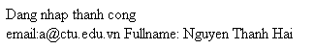

Dùng Cookies lưu lại tên đăng nhập, email và điều hướng
Chỉnh sửa lại log.php với code sau để khi đăng nhập thành công chuyển sang 1 trang chủ, còn nếu không đúng thì trở lại trang đăng nhập

Log.php (modified)
<?php
$servername = "localhost";
$username = "root";
$password = "";
$dbname = "qlbanhang";

// Create connection
$conn = new mysqli($servername, $username, $password, $dbname);
// Check connection
if ($conn->connect_error) {
die("Connection failed: " . $conn->connect_error);
}

$sql = "select id, fullname, email from customers where email = '".$_POST["email"]."' and password = '".md5($_POST["pass"])."'";

$result = $conn->query($sql);

if ($result->num_rows > 0) {

$row = $result->fetch_assoc();

$cookie_name = "user";
$cookie_value = $row['email'] ;
setcookie($cookie_name, $cookie_value, time() + (86400 / 24), "/");
setcookie("fullname", $row['fullname'], time() + (86400 / 24), "/");
setcookie("id", $row['id'], time() + (86400 / 24), "/");

header('Location: homepage.php');

} else {
echo "Error: " . $sql . "<br>" . $conn->error;
//Tro ve trang dang nhap sau 3 giay
header('Refresh: 3;url=login.php');

}

$conn->close();
?>

Tạo 1 trang chủ để khi đăng nhập thành công chuyển qua trang chủ này:

Homepage.php

<!DOCTYPE html>
<html>
<title>W3.CSS Template</title>
<meta charset="UTF-8">
<meta name="viewport" content="width=device-width, initial-scale=1">
<link rel="stylesheet" href="https://www.w3schools.com/w3css/4/w3.css">
<link rel="stylesheet" href="https://fonts.googleapis.com/css?family=Roboto">
<link rel="stylesheet" href="https://fonts.googleapis.com/css?family=Montserrat">
<link rel="stylesheet" href="https://cdnjs.cloudflare.com/ajax/libs/font-awesome/4.7.0/css/font-awesome.min.css">
<style>
.w3-sidebar a {font-family: "Roboto", sans-serif}
body,h1,h2,h3,h4,h5,h6,.w3-wide {font-family: "Montserrat", sans-serif;}
</style>
<body class="w3-content" style="max-width:1200px">

<!-- Sidebar/menu -->
<nav class="w3-sidebar w3-bar-block w3-white w3-collapse w3-top" style="z-index:3;width:250px" id="mySidebar">
<div class="w3-container w3-display-container w3-padding-16">
<i onclick="w3_close()" class="fa fa-remove w3-hide-large w3-button w3-display-topright"></i>
<h3 class="w3-wide"><b>
<?php
$cookie_name = "fullname";
echo 'Chao ban '.$_COOKIE[$cookie_name];

?>

</b></h3>
</div>
<div class="w3-padding-64 w3-large w3-text-grey" style="font-weight:bold">
<a href="#" class="w3-bar-item w3-button">Shirts</a>
<a href="#" class="w3-bar-item w3-button">Dresses</a>

<div id="demoAcc" class="w3-bar-block w3-hide w3-padding-large w3-medium">
<a href="#" class="w3-bar-item w3-button w3-light-grey"><i class="fa fa-caret-right w3-margin-right"></i>Skinny</a>
<a href="#" class="w3-bar-item w3-button">Relaxed</a>
<a href="#" class="w3-bar-item w3-button">Bootcut</a>
<a href="#" class="w3-bar-item w3-button">Straight</a>
</div>
<a href="#" class="w3-bar-item w3-button">Jackets</a>
<a href="#" class="w3-bar-item w3-button">Gymwear</a>
<a href="#" class="w3-bar-item w3-button">Blazers</a>
<a href="#" class="w3-bar-item w3-button">Shoes</a>
</div>
<a href="#footer" class="w3-bar-item w3-button w3-padding">Contact</a>
<a href="javascript:void(0)" class="w3-bar-item w3-button w3-padding" onclick="document.getElementById('newsletter').style.display='block'">Newsletter</a>
<a href="#footer" class="w3-bar-item w3-button w3-padding">Subscribe</a>
</nav>

<!-- Top menu on small screens -->
<header class="w3-bar w3-top w3-hide-large w3-black w3-xlarge">
<div class="w3-bar-item w3-padding-24 w3-wide">LOGO</div>
<a href="javascript:void(0)" class="w3-bar-item w3-button w3-padding-24 w3-right" onclick="w3_open()"><i class="fa fa-bars"></i></a>
</header>

<!-- Overlay effect when opening sidebar on small screens -->
<div class="w3-overlay w3-hide-large" onclick="w3_close()" style="cursor:pointer" title="close side menu" id="myOverlay"></div>

<!-- !PAGE CONTENT! -->
<div class="w3-main" style="margin-left:250px">

<!-- Push down content on small screens -->
<div class="w3-hide-large" style="margin-top:83px"></div>

<!-- Top header -->
<header class="w3-container w3-xlarge">

<p class="w3-right">
<i class="fa fa-shopping-cart w3-margin-right"></i>
<i class="fa fa-search"></i>
</p>
</header>

<div class="w3-container w3-text-grey" id="jeans">
<p>8 items</p>
</div>

<!-- Subscribe section -->
<div class="w3-container w3-black w3-padding-32">
<h1>Subscribe</h1>
<p>To get special offers and VIP treatment:</p>
<p><input class="w3-input w3-border" type="text" placeholder="Enter e-mail" style="width:100%"></p>
<button type="button" class="w3-button w3-red w3-margin-bottom">Subscribe</button>
</div>

<!-- Footer -->
<footer class="w3-padding-64 w3-light-grey w3-small w3-center" id="footer">
<div class="w3-row-padding">
<div class="w3-col s4">
<h4>Contact</h4>
<p>Questions? Go ahead.</p>
<form action="/action_page.php" target="_blank">
<p><input class="w3-input w3-border" type="text" placeholder="Name" name="Name" required></p>
<p><input class="w3-input w3-border" type="text" placeholder="Email" name="Email" required></p>
<p><input class="w3-input w3-border" type="text" placeholder="Subject" name="Subject" required></p>
<p><input class="w3-input w3-border" type="text" placeholder="Message" name="Message" required></p>
<button type="submit" class="w3-button w3-block w3-black">Send</button>
</form>
</div>

<div class="w3-col s4">
<h4>About</h4>
<p><a href="#">About us</a></p>
<p><a href="#">We're hiring</a></p>
<p><a href="#">Support</a></p>
<p><a href="#">Find store</a></p>
<p><a href="#">Shipment</a></p>
<p><a href="#">Payment</a></p>
<p><a href="#">Gift card</a></p>
<p><a href="#">Return</a></p>
<p><a href="#">Help</a></p>
</div>

<div class="w3-col s4 w3-justify">
<h4>Store</h4>
<p><i class="fa fa-fw fa-map-marker"></i> Company Name</p>
<p><i class="fa fa-fw fa-phone"></i> 0044123123</p>
<p><i class="fa fa-fw fa-envelope"></i> ex@mail.com</p>
<h4>We accept</h4>
<p><i class="fa fa-fw fa-cc-amex"></i> Amex</p>
<p><i class="fa fa-fw fa-credit-card"></i> Credit Card</p>
<br>
<i class="fa fa-facebook-official w3-hover-opacity w3-large"></i>
<i class="fa fa-instagram w3-hover-opacity w3-large"></i>
<i class="fa fa-snapchat w3-hover-opacity w3-large"></i>
<i class="fa fa-pinterest-p w3-hover-opacity w3-large"></i>
<i class="fa fa-twitter w3-hover-opacity w3-large"></i>
<i class="fa fa-linkedin w3-hover-opacity w3-large"></i>
</div>
</div>
</footer>

<div class="w3-black w3-center w3-padding-24">Powered by <a href="https://www.w3schools.com/w3css/default.asp" title="W3.CSS" target="_blank" class="w3-hover-opacity">w3.css</a></div>

<!-- End page content -->
</div>

<!-- Newsletter Modal -->
<div id="newsletter" class="w3-modal">
<div class="w3-modal-content w3-animate-zoom" style="padding:32px">
<div class="w3-container w3-white w3-center">
<i onclick="document.getElementById('newsletter').style.display='none'" class="fa fa-remove w3-right w3-button w3-transparent w3-xxlarge"></i>
<h2 class="w3-wide">NEWSLETTER</h2>
<p>Join our mailing list to receive updates on new arrivals and special offers.</p>
<p><input class="w3-input w3-border" type="text" placeholder="Enter e-mail"></p>
<button type="button" class="w3-button w3-padding-large w3-red w3-margin-bottom" onclick="document.getElementById('newsletter').style.display='none'">Subscribe</button>
</div>
</div>
</div>

<script>
// Accordion
function myAccFunc() {
var x = document.getElementById("demoAcc");
if (x.className.indexOf("w3-show") == -1) {
x.className += " w3-show";
} else {
x.className = x.className.replace(" w3-show", "");
}
}

// Click on the "Jeans" link on page load to open the accordion for demo purposes
document.getElementById("myBtn").click();

// Open and close sidebar
function w3_open() {
document.getElementById("mySidebar").style.display = "block";
document.getElementById("myOverlay").style.display = "block";
}

function w3_close() {
document.getElementById("mySidebar").style.display = "none";
document.getElementById("myOverlay").style.display = "none";
}
</script>

</body>
</html>

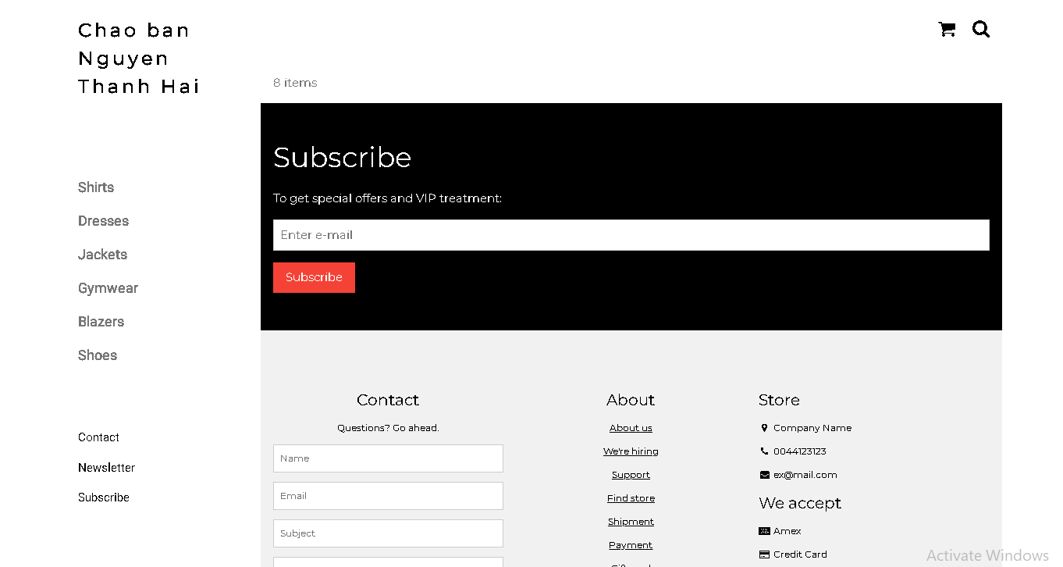

Upload tập tin
Upload file, chúng ta tạo form giao diện để upload file ảnh upload-img.php

Upload-img.php

<!DOCTYPE html>
<html>
<body>

<form action="upload.php" method="post" enctype="multipart/form-data">
Ban chon 1 anh de lam profile:
<input type="file" name="fileToUpload" id="fileToUpload">
<input type="submit" value="Upload Image" name="submit">
</form>

</body>
</html>

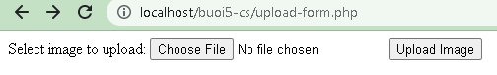

Tập tin upload.php xử lý hành động

upload.php

<?php
$target_dir = "uploads/";
$target_file = $target_dir . basename($_FILES["fileToUpload"]["name"]);
$uploadOk = 1;
$imageFileType = strtolower(pathinfo($target_file,PATHINFO_EXTENSION));

// Check if image file is a actual image or fake image
if(isset($_POST["submit"])) {
$check = getimagesize($_FILES["fileToUpload"]["tmp_name"]);
if($check !== false) {
echo "File is an image - " . $check["mime"] . ".";
$uploadOk = 1;
} else {
echo "File is not an image.";
$uploadOk = 0;
}
}

// Check if file already exists
if (file_exists($target_file)) {
echo "Sorry, file already exists.";
$uploadOk = 0;
}

// Check file size
if ($_FILES["fileToUpload"]["size"] > 500000) {
echo "Sorry, your file is too large.";
$uploadOk = 0;
}

// Allow certain file formats
if($imageFileType != "jpg" && $imageFileType != "png" && $imageFileType != "jpeg"
&& $imageFileType != "gif" ) {
echo "Sorry, only JPG, JPEG, PNG & GIF files are allowed.";
$uploadOk = 0;
}

// Check if $uploadOk is set to 0 by an error
if ($uploadOk == 0) {
echo "Sorry, your file was not uploaded.";
// if everything is ok, try to upload file
} else {
if (move_uploaded_file($_FILES["fileToUpload"]["tmp_name"], $target_file)) {
echo "The file ". htmlspecialchars( basename( $_FILES["fileToUpload"]["name"])). " has been uploaded.";
} else {
echo "Sorry, there was an error uploading your file.";
}
}
?>

Sau khi chúng ta upload thành công giao diện sau sẽ hiển thị
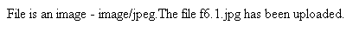

Upload ảnh và lưu dữ liệu về ảnh trong CSDL

Trong phần này chúng ta minh họa tải tập tin ảnh làm ảnh profile của người dùng

Upload-img.php (modified)
<!DOCTYPE html>
<html>
<body>

<form action="upload-csdl.php" method="post" enctype="multipart/form-data">
Ban chon 1 anh de lam profile:
<input type="file" name="fileToUpload" id="fileToUpload">
<input type="submit" value="Upload Image" name="submit">
</form>

</body>
</html>

Thêm cột để lưu đường dẫn ảnh:

ALTER TABLE `customers` ADD `img_profile` VARCHAR(100);

Upload-csdl.php

<?php
$target_dir = "uploads/";
$target_file = $target_dir . basename($_FILES["fileToUpload"]["name"]);
$uploadOk = 1;
$imageFileType = strtolower(pathinfo($target_file,PATHINFO_EXTENSION));

// Check if image file is a actual image or fake image
if(isset($_POST["submit"])) {
$check = getimagesize($_FILES["fileToUpload"]["tmp_name"]);
if($check !== false) {
echo "File is an image - " . $check["mime"] . ".";
$uploadOk = 1;
} else {
echo "File is not an image.";
$uploadOk = 0;
}
}

// Check if file already exists
if (file_exists($target_file)) {
echo "Sorry, file already exists.";
$uploadOk = 0;
}

// Check file size
if ($_FILES["fileToUpload"]["size"] > 500000) {
echo "Sorry, your file is too large.";
$uploadOk = 0;
}

// Allow certain file formats
if($imageFileType != "jpg" && $imageFileType != "png" && $imageFileType != "jpeg"
&& $imageFileType != "gif" ) {
echo "Sorry, only JPG, JPEG, PNG & GIF files are allowed.";
$uploadOk = 0;
}

// Check if $uploadOk is set to 0 by an error
if ($uploadOk == 0) {
echo "Sorry, your file was not uploaded.";
// if everything is ok, try to upload file
} else {
if (move_uploaded_file($_FILES["fileToUpload"]["tmp_name"], $target_file)) {
echo "The file ". htmlspecialchars( basename( $_FILES["fileToUpload"]["name"])). " has been uploaded.";
echo '<br>';

$servername = "localhost";
$username = "root";
$password = "";
$dbname = "qlbanhang";

// Create connection
$conn = new mysqli($servername, $username, $password, $dbname);
// Check connection
if ($conn->connect_error) {
die("Connection failed: " . $conn->connect_error);
}

$id = $_COOKIE['id'];
$sql = "UPDATE customers set img_profile = '".$_FILES["fileToUpload"]["name"]."'";
$sql = $sql. " WHERE ID='".$id."'";

echo $sql;
if ($conn->query($sql) == TRUE) {
echo 'cap nhat csdl thanh cong!<br>';
echo '<a href="homepage.php">Trang chu</a>';
} else {
echo "Error: " . $sql . "<br>" . $conn->error;
}

} else {
echo "Sorry, there was an error uploading your file.";
}
}
?>

Homepage.php (modified với ảnh profile)

<!DOCTYPE html>
<html>
<title>W3.CSS Template</title>
<meta charset="UTF-8">
<meta name="viewport" content="width=device-width, initial-scale=1">
<link rel="stylesheet" href="https://www.w3schools.com/w3css/4/w3.css">
<link rel="stylesheet" href="https://fonts.googleapis.com/css?family=Roboto">
<link rel="stylesheet" href="https://fonts.googleapis.com/css?family=Montserrat">
<link rel="stylesheet" href="https://cdnjs.cloudflare.com/ajax/libs/font-awesome/4.7.0/css/font-awesome.min.css">
<style>
.w3-sidebar a {font-family: "Roboto", sans-serif}
body,h1,h2,h3,h4,h5,h6,.w3-wide {font-family: "Montserrat", sans-serif;}
</style>
<body class="w3-content" style="max-width:1200px">

<!-- Sidebar/menu -->
<nav class="w3-sidebar w3-bar-block w3-white w3-collapse w3-top" style="z-index:3;width:250px" id="mySidebar">
<div class="w3-container w3-display-container w3-padding-16">
<i onclick="w3_close()" class="fa fa-remove w3-hide-large w3-button w3-display-topright"></i>
<h3 class="w3-wide"><b>
<?php
$cookie_name = "fullname";
echo 'Chao ban '.$_COOKIE[$cookie_name];

//them doan nay de lay duong dan anh
$servername = "localhost";
$username = "root";
$password = "";
$dbname = "qlbanhang";

// Create connection
$conn = new mysqli($servername, $username, $password, $dbname);
// Check connection
if ($conn->connect_error) {
die("Connection failed: " . $conn->connect_error);
}

$sql = "select img_profile from customers where id = '".$_COOKIE['id']."'";
//echo $sql;
$result = $conn->query($sql);

//print_r($result);
if ( $result->num_rows > 0) {
//lay link anh tu csdl da luu de hien thi cac anh duoc luu trong uploads
$row = $result->fetch_assoc();
echo '<img src="'.'./uploads/'.$row['img_profile'].'" alt="Anh profile">';
}
?>

</b></h3>
</div>
<div class="w3-padding-64 w3-large w3-text-grey" style="font-weight:bold">
<a href="#" class="w3-bar-item w3-button">Shirts</a>
<a href="#" class="w3-bar-item w3-button">Dresses</a>

<div id="demoAcc" class="w3-bar-block w3-hide w3-padding-large w3-medium">
<a href="#" class="w3-bar-item w3-button w3-light-grey"><i class="fa fa-caret-right w3-margin-right"></i>Skinny</a>
<a href="#" class="w3-bar-item w3-button">Relaxed</a>
<a href="#" class="w3-bar-item w3-button">Bootcut</a>
<a href="#" class="w3-bar-item w3-button">Straight</a>
</div>
<a href="#" class="w3-bar-item w3-button">Jackets</a>
<a href="#" class="w3-bar-item w3-button">Gymwear</a>
<a href="#" class="w3-bar-item w3-button">Blazers</a>
<a href="#" class="w3-bar-item w3-button">Shoes</a>
</div>
<a href="#footer" class="w3-bar-item w3-button w3-padding">Contact</a>
<a href="javascript:void(0)" class="w3-bar-item w3-button w3-padding" onclick="document.getElementById('newsletter').style.display='block'">Newsletter</a>
<a href="#footer" class="w3-bar-item w3-button w3-padding">Subscribe</a>
</nav>

<!-- Top menu on small screens -->
<header class="w3-bar w3-top w3-hide-large w3-black w3-xlarge">
<div class="w3-bar-item w3-padding-24 w3-wide">LOGO</div>
<a href="javascript:void(0)" class="w3-bar-item w3-button w3-padding-24 w3-right" onclick="w3_open()"><i class="fa fa-bars"></i></a>
</header>

<!-- Overlay effect when opening sidebar on small screens -->
<div class="w3-overlay w3-hide-large" onclick="w3_close()" style="cursor:pointer" title="close side menu" id="myOverlay"></div>

<!-- !PAGE CONTENT! -->
<div class="w3-main" style="margin-left:250px">

<!-- Push down content on small screens -->
<div class="w3-hide-large" style="margin-top:83px"></div>

<!-- Top header -->
<header class="w3-container w3-xlarge">

<p class="w3-right">
<i class="fa fa-shopping-cart w3-margin-right"></i>
<i class="fa fa-search"></i>
</p>
</header>

<div class="w3-container w3-text-grey" id="jeans">
<p>8 items</p>
</div>

<!-- Subscribe section -->
<div class="w3-container w3-black w3-padding-32">
<h1>Subscribe</h1>
<p>To get special offers and VIP treatment:</p>
<p><input class="w3-input w3-border" type="text" placeholder="Enter e-mail" style="width:100%"></p>
<button type="button" class="w3-button w3-red w3-margin-bottom">Subscribe</button>
</div>

<!-- Footer -->
<footer class="w3-padding-64 w3-light-grey w3-small w3-center" id="footer">
<div class="w3-row-padding">
<div class="w3-col s4">
<h4>Contact</h4>
<p>Questions? Go ahead.</p>
<form action="/action_page.php" target="_blank">
<p><input class="w3-input w3-border" type="text" placeholder="Name" name="Name" required></p>
<p><input class="w3-input w3-border" type="text" placeholder="Email" name="Email" required></p>
<p><input class="w3-input w3-border" type="text" placeholder="Subject" name="Subject" required></p>
<p><input class="w3-input w3-border" type="text" placeholder="Message" name="Message" required></p>
<button type="submit" class="w3-button w3-block w3-black">Send</button>
</form>
</div>

<div class="w3-col s4">
<h4>About</h4>
<p><a href="#">About us</a></p>
<p><a href="#">We're hiring</a></p>
<p><a href="#">Support</a></p>
<p><a href="#">Find store</a></p>
<p><a href="#">Shipment</a></p>
<p><a href="#">Payment</a></p>
<p><a href="#">Gift card</a></p>
<p><a href="#">Return</a></p>
<p><a href="#">Help</a></p>
</div>

<div class="w3-col s4 w3-justify">
<h4>Store</h4>
<p><i class="fa fa-fw fa-map-marker"></i> Company Name</p>
<p><i class="fa fa-fw fa-phone"></i> 0044123123</p>
<p><i class="fa fa-fw fa-envelope"></i> ex@mail.com</p>
<h4>We accept</h4>
<p><i class="fa fa-fw fa-cc-amex"></i> Amex</p>
<p><i class="fa fa-fw fa-credit-card"></i> Credit Card</p>
<br>
<i class="fa fa-facebook-official w3-hover-opacity w3-large"></i>
<i class="fa fa-instagram w3-hover-opacity w3-large"></i>
<i class="fa fa-snapchat w3-hover-opacity w3-large"></i>
<i class="fa fa-pinterest-p w3-hover-opacity w3-large"></i>
<i class="fa fa-twitter w3-hover-opacity w3-large"></i>
<i class="fa fa-linkedin w3-hover-opacity w3-large"></i>
</div>
</div>
</footer>

<div class="w3-black w3-center w3-padding-24">Powered by <a href="https://www.w3schools.com/w3css/default.asp" title="W3.CSS" target="_blank" class="w3-hover-opacity">w3.css</a></div>

<!-- End page content -->
</div>

<!-- Newsletter Modal -->
<div id="newsletter" class="w3-modal">
<div class="w3-modal-content w3-animate-zoom" style="padding:32px">
<div class="w3-container w3-white w3-center">
<i onclick="document.getElementById('newsletter').style.display='none'" class="fa fa-remove w3-right w3-button w3-transparent w3-xxlarge"></i>
<h2 class="w3-wide">NEWSLETTER</h2>
<p>Join our mailing list to receive updates on new arrivals and special offers.</p>
<p><input class="w3-input w3-border" type="text" placeholder="Enter e-mail"></p>
<button type="button" class="w3-button w3-padding-large w3-red w3-margin-bottom" onclick="document.getElementById('newsletter').style.display='none'">Subscribe</button>
</div>
</div>
</div>

<script>
// Accordion
function myAccFunc() {
var x = document.getElementById("demoAcc");
if (x.className.indexOf("w3-show") == -1) {
x.className += " w3-show";
} else {
x.className = x.className.replace(" w3-show", "");
}
}

// Click on the "Jeans" link on page load to open the accordion for demo purposes
document.getElementById("myBtn").click();

// Open and close sidebar
function w3_open() {
document.getElementById("mySidebar").style.display = "block";
document.getElementById("myOverlay").style.display = "block";
}

function w3_close() {
document.getElementById("mySidebar").style.display = "none";
document.getElementById("myOverlay").style.display = "none";
}
</script>

</body>
</html>

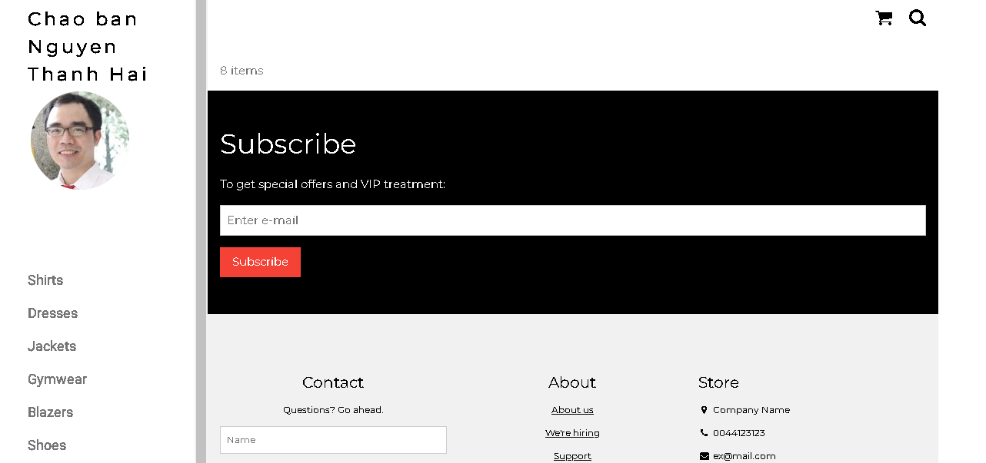

Ở đây do biểu diễn từng bước nên đoạn này chúng ta lấy dữ liệu link ảnh profile từ id của người dùng. Trong thực tế, các bạn có thể lưu link ảnh profile vào cookie/session ngay từ khi đăng nhập.

Upload file csv và đọc dữ liệu vào mảng
Thao tác đọc dữ liệu từ các tập tin là quan trọng, giúp chúng ta backup dữ liệu và phục hồi hay import dữ liệu từ các hệ thống khác. Ví dụ dưới đây giúp minh họa cho các bạn thao tác đọc dữ liệu từ tập tin csv và từ đó đưa vào mảng để phục vụ cho việc xử lý.

read-csv.php
<?php
$csv = array();
$name_file = 'cus.csv';
$lines = file($name_file, FILE_IGNORE_NEW_LINES);

//dua du lieu tu file csv vao mang:
foreach ($lines as $key => $value)
{
$csv[$key] = str_getcsv($value);
}

//in mang
echo '<pre>';
print_r($csv);
echo '</pre>';
?>
Tạo tập tin cus.csv với dữ liệu như sau
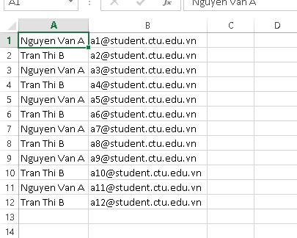
Khi chạy code đọc trên ta sẽ có dữ liệu đã được đưa vào mảng và hiển thị

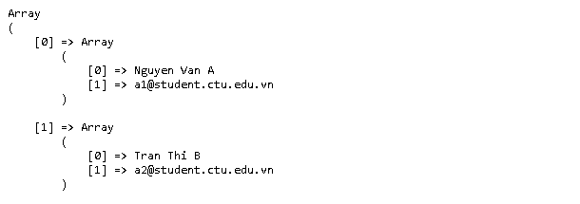

Yêu cầu bài thực hành:
- Bạn hãy chạy tất cả các lệnh hướng dẫn ở trên và chụp lại màn hình kết quả.

Tạo Cookies
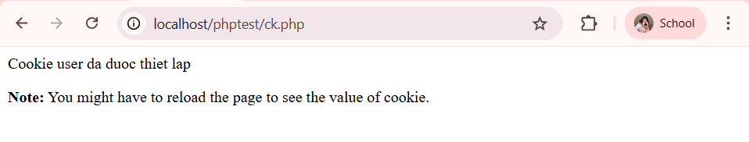

Tạo 1 trang đăng ký người dùng với mật khẩu được mã hóa
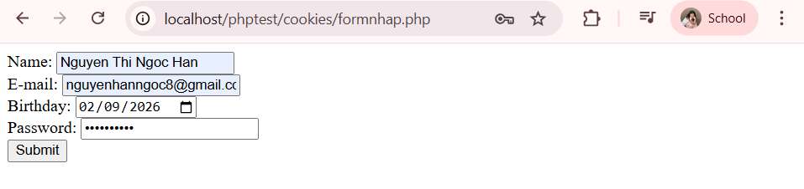
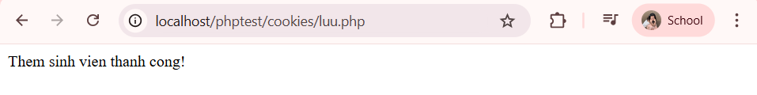

Tạo form đăng nhập
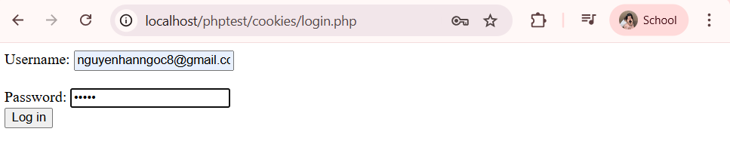
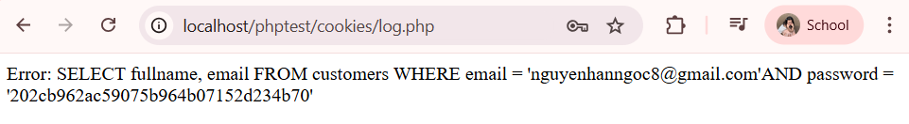
Dùng Cookies lưu lại tên đăng nhập, email và điều hướng
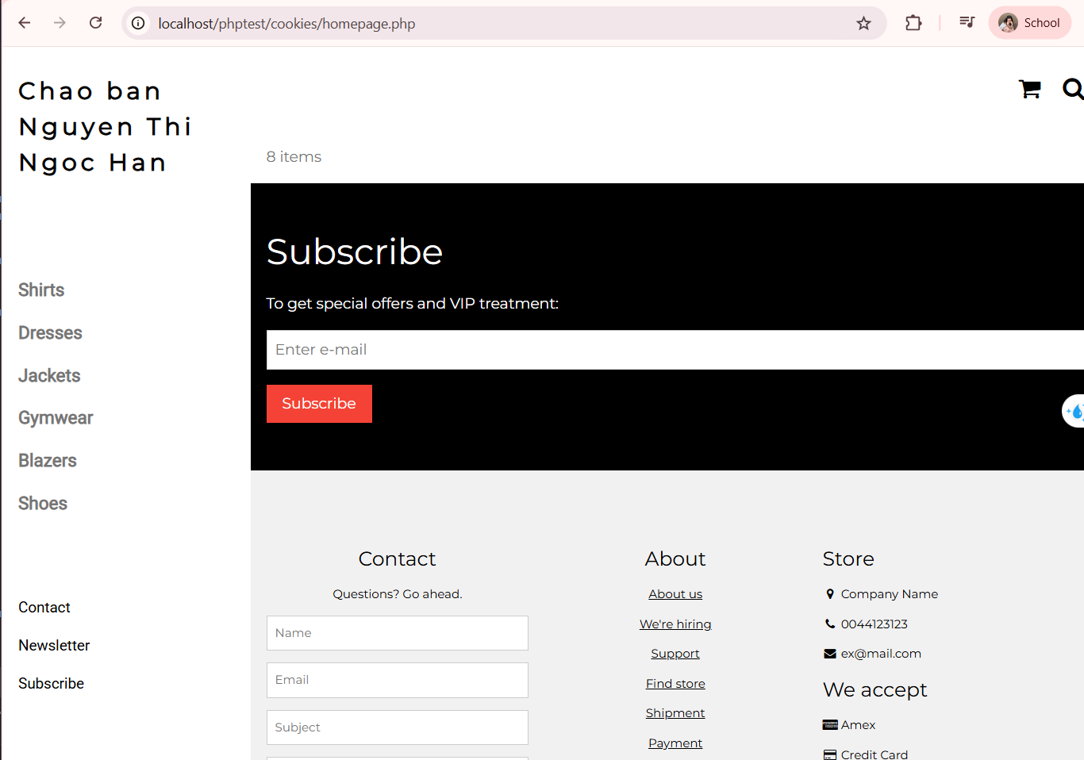Upload tập tin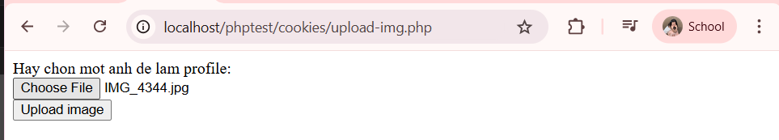

Upload ảnh và lưu dữ liệu về ảnh trong CSDL
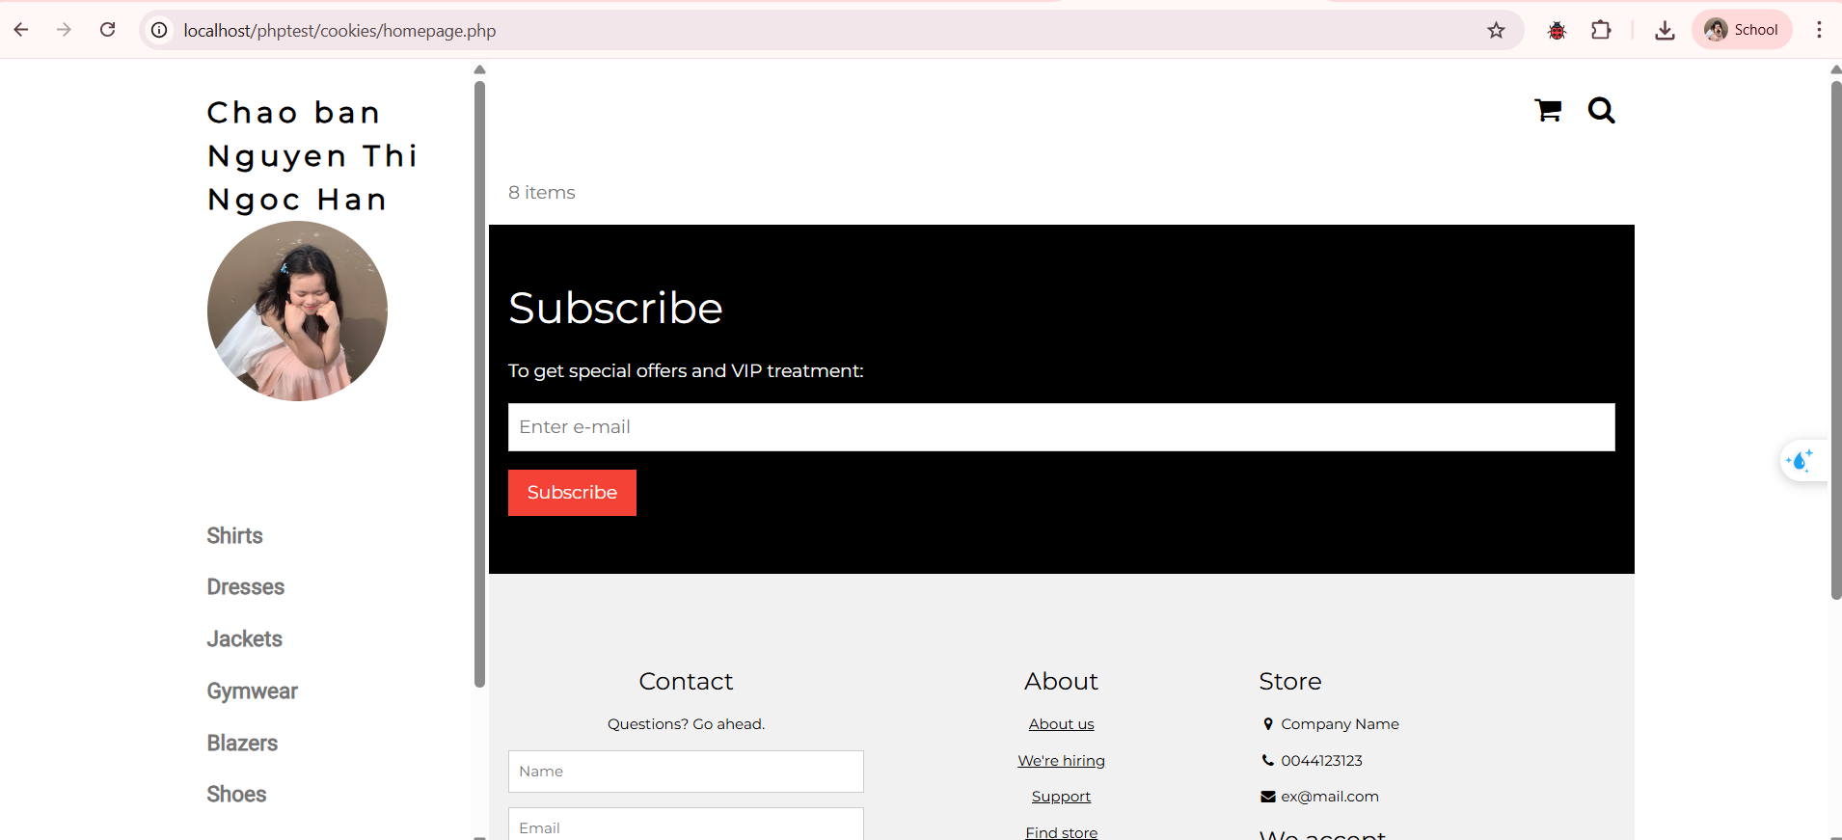

Upload file csv và đọc dữ liệu vào mảng
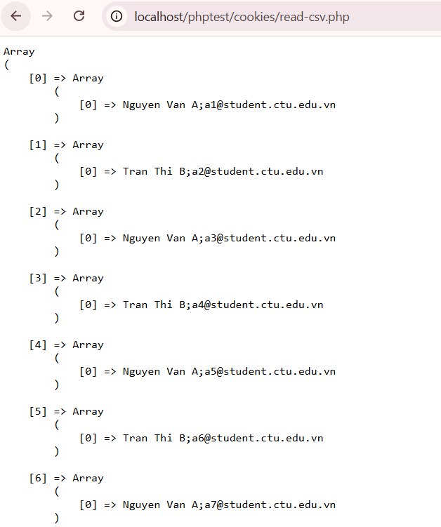

- Trong vài trường hợp, hacker có thể sử dụng các kỹ thuật SQL Injection để hack hệ thống của bạn. Bạn hãy trình bày SQL Injection là gì và thử các ví dụ trình bày trong . Ứng dụng kỹ thuật đó vào trang đăng nhập mà bạn đã tạo, chụp lại các kết quả.
- SQL Injection là kỹ thuật tấn công bằng cách chèn (inject) mã SQL độc hại vào câu truy vấn SQL của ứng dụng. Nó xảy ra khi:
  - Ứng dụng ghép chuỗi trực tiếp dữ liệu người dùng nhập vào câu SQL
  - Không kiểm tra / không dùng prepared statement
Khi đó hacker có thể:
- Bỏ qua đăng nhập
- Xem toàn bộ dữ liệu
- Xóa dữ liệu
- Thậm chí chiếm quyền admin

- Dựa vào link, bạn hãy cho biết Cookie là gì, diễn giải ý nghĩa các tham số trong setcookie(). Cách lưu, lấy, xóa giá trị trong cookie.
- Cookie là một tập tin nhỏ được lưu trữ trên trình duyệt của người dùng khi họ truy cập vào một website. Cookie giúp website ghi nhớ thông tin người dùng trong một khoảng thời gian nhất định.
- setcookie() setcookie(name, value, expire, path, domain, secure, httponly);
- Ý nghĩa các tham số:

- Name: Tên của cookie.
- Value: Giá trị lưu trữ trong cookie.
- Expire: Thời gian hết hạn (tính bằng giây).
- Path: Đường dẫn mà cookie có hiệu lực (thường dùng "/").
- Domain: Tên miền sử dụng cookie.
- Secure: Nếu đặt là true thì cookie chỉ gửi qua HTTPS.
- Httponly: Nếu đặt là true thì JavaScript không thể truy cập cookie (tăng bảo mật).
- Dựa vào link, bạn hãy cho biết Session dùng để làm gì. Cách lưu, lấy, xóa giá trị trong Session.
- Session dùng để lưu trữ thông tin của một người dùng (user) trên server và có thể truy cập được trên nhiều trang khác nhau trong website.
- Mục đích chính của Session là giữ trạng thái giữa các trang, bởi vì HTTP mặc định không giữ trạng thái (stateless). Ví dụ: dùng để lưu thông tin đăng nhập, giỏ hàng, tùy chọn người dùng…
- Thông tin Session không lưu trên trình duyệt, mà được lưu server, trong khi trình duyệt chỉ lưu một session id (PHPSESSID) để nhận dạng
- Cách lưu giá trị vào Session: sau khi gọi session_start(),có thể lưu dữ liệu vào biến session bằng mảng $_SESSION:
<?php
session_start();
$_SESSION["username"] = "NgocHan";
$_SESSION["email"] = "han@example.com";
?>
- Cách lấy (truy xuất) giá trị Session: để lấy dữ liệu đã lưu trong session:

<?php
session_start();

echo $_SESSION["username"];
echo $_SESSION["email"];
?>
- Cách xóa giá trị trong Session
- Xóa một biến Session (các biến session khác vẫn còn) ta dùng unset():

<?php
session_start();
unset($_SESSION["username"]); // Xóa biến username
?>

- Xóa tất cả biến Session (dữ liệu trong session không còn nhưng session vẫn tồn tại) ta dùng session_unset():

<?php
session_start();
session_unset(); // Xóa tất cả biến session
?>
- Hủy Session hoàn toàn (xóa sạch session data và kết thúc phiên làm việc) ta dùng session_destroy():

<?php
session_start();
session_destroy(); // Hủy session
?>

- Bạn hãy so sánh Cookie và Session.

Tiêu chí | Cookie | Session
Nơi lưu trữ | Trình duyệt (client) | Server
Bảo mật | Thấp hơn | Cao hơn
Dung lượng | ~4KB | Lớn hơn (tùy server)
Thời gian tồn tại | Theo thời gian cài đặt | Đến khi đóng trình duyệt hoặc hủy Session
Cách tạo | setcookie() | session_start()
Lưu dữ liệu | $_COOKIE | $_SESSION
Ứng dụng | Ghi nhớ đăng nhập, ngôn ngữ | Đăng nhập, giỏ hàng

- Chỉnh sửa các đoạn gán, khởi tạo, lấy giá trị cookie trong log.php và homepage.php thay bằng cách dùng Session. Tạo tập tin thoat.php để xóa các giá trị trong session, cookie thực hiện chức năng log out khỏi hệ thống.
<?php
session_start();

// 1️⃣ XÓA TOÀN BỘ SESSION
session_unset(); // Xóa tất cả biến session
session_destroy(); // Hủy session

// 2️⃣ XÓA COOKIE (nếu có dùng trước đó)
if (isset($_COOKIE["user"])) {
setcookie("user", "", time() - 3600, "/");
}

if (isset($_COOKIE["fullname"])) {
setcookie("fullname", "", time() - 3600, "/");
}

if (isset($_COOKIE["id"])) {
setcookie("id", "", time() - 3600, "/");
}

// 3️⃣ CHUYỂN VỀ TRANG ĐĂNG NHẬP
header("Location: login.php");
exit();
?>

- Bạn hãy tạo form sua_mk.php cho phép người dùng chỉnh sửa mật khẩu sau khi đăng nhập. Yêu cầu gồm 3 input: ô để nhập mật khẩu cũ, 1 ô để nhập mật khẩu mới, 1 ô cho phép nhập mật lại mật khẩu mới. Khi nhập xong cần đảm bảo: mật khẩu cũ là khớp với CSDL đang lưu, 2 ô nhập mật khẩu mới phải khớp với nhau và không giống với mật khẩu cũ, nếu đáp ứng điều kiện thì tiến hành băm mật khẩu với md5 và lưu mật khẩu mới vào CSDL.
<?php
session_start();

// Kiểm tra đã đăng nhập chưa
if (!isset($_SESSION["id"])) {
header("Location: login.php");
exit();
}

$servername = "localhost";
$username = "root";
$password = "";
$dbname = "qlbanhang";

$conn = new mysqli($servername, $username, $password, $dbname);
if ($conn->connect_error) {
die("Connection failed: " . $conn->connect_error);
}

$message = "";

if ($_SERVER["REQUEST_METHOD"] == "POST") {

$id = $_SESSION["id"];
$old_pass = md5($_POST["old_pass"]);
$new_pass = $_POST["new_pass"];
$re_pass = $_POST["re_pass"];

// Lấy mật khẩu hiện tại trong CSDL
$sql = "SELECT password FROM customers WHERE id = '$id'";
$result = $conn->query($sql);

if ($result->num_rows > 0) {
$row = $result->fetch_assoc();
$current_pass = $row["password"];

// Kiểm tra mật khẩu cũ đúng
if ($old_pass != $current_pass) {
$message = "Mật khẩu cũ không đúng!";
}
// Kiểm tra mật khẩu mới nhập lại có khớp không
elseif ($new_pass != $re_pass) {
$message = "Mật khẩu mới nhập lại không khớp!";
}
// Kiểm tra mật khẩu mới không được trùng mật khẩu cũ
elseif (md5($new_pass) == $current_pass) {
$message = "Mật khẩu mới không được trùng mật khẩu cũ!";
}
else {
// Cập nhật mật khẩu mới (băm md5)
$new_pass_md5 = md5($new_pass);
$update = "UPDATE customers SET password = '$new_pass_md5' WHERE id = '$id'";

if ($conn->query($update) === TRUE) {
$message = "Đổi mật khẩu thành công!";
} else {
$message = "Lỗi khi cập nhật!";
}
}
}
}

$conn->close();
?>

<!DOCTYPE html>
<html>
<head>
<title>Sửa mật khẩu</title>
</head>
<body>

<h2>Đổi mật khẩu</h2>

<form method="POST">
<label>Mật khẩu cũ:</label><br>
<input type="password" name="old_pass" required><br><br>

<label>Mật khẩu mới:</label><br>
<input type="password" name="new_pass" required><br><br>

<label>Nhập lại mật khẩu mới:</label><br>
<input type="password" name="re_pass" required><br><br>

<button type="submit">Cập nhật</button>
</form>

<p style="color:red;"><?php echo $message; ?></p>

</body>
</html>

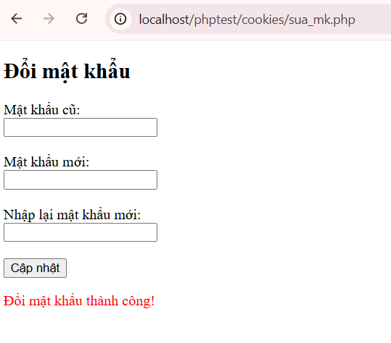
- Bạn đọc trong để tìm hiểu và mô tả các cơ chế, các hàm/thủ tục để thực hiện việc upload.
- Cơ chế upload file trong PHP
Upload file là việc gửi file từ máy người dùng (client) lên server để lưu trữ. PHP hỗ trợ upload file rất dễ dàng bằng cách sử dụng biến siêu toàn cục $_FILES cùng một form HTML đặc biệt
Khi người dùng gửi form thì file được upload tạm thời vào một thư mục tạm trên server. Sau đó, PHP cho phép chúng ta di chuyển file từ thư mục tạm đến thư mục lưu trữ cuối cùng bằng hàm move_uploaded_file() (PHP > 4.0.3).
- Các hàm/thủ tục để thực hiện việc upload
$_FILES : Biến siêu toàn cục chứa thông tin file upload.
move_uploaded_file() :Di chuyển file từ thư mục tạm (tmp) sang thư mục lưu trữ chính thức.
basename() : Lấy tên file (loại bỏ đường dẫn).
getimagesize() :Kiểm tra file có phải ảnh hay không.
file_exists() : Kiểm tra file đã tồn tại chưa.
pathinfo() :Lấy phần mở rộng file (đuôi file).
- Bạn hãy đọc, mô tả chức năng của hàm này và các tham số trong hàm (tham khảo thêm từ read-csv.php).
- Hàm file() trong PHP được dùng để đọc toàn bộ nội dung của một file vào trong một mảng (array). Mỗi phần tử của mảng sẽ tương ứng với 1 dòng trong file.
- Cú pháp của file():
file(string $filename, int $flags = 0, ?resource $context = null): array|false
- Mô tả tham số:
  - $filenam (kiểu string): Tên file (đường dẫn file) cần đọc.
  - $flags (kiểu integer): Tùy chọn điều khiển cách đọc file .
FILE_IGNORE_NEW_LINES : Bỏ qua ký tự xuống dòng ở cuối mỗi dòng.
FILE_SKIP_EMPTY_LINES: Bỏ qua các dòng rỗng.
FILE_USE_INCLUDE_PATH: Tìm file trong include path nếu không tìm thấy ngay.
- $context (kiểu resource): Tùy chọn ngữ cảnh stream
- Giá trị trả về:
  - Thành công: trả về mảng các dòng file
  - Thất bại: trả về false

- Bạn hãy tạo 1 tập tin csv ít nhất 10 dòng dữ liệu với các cột dữ liệu như bảng customer trong csdl qlbanhang. Tạo tập tin upload-csv.php với giao diện cho phép upload các tập tin csv, và tập tin upload-csv-processing để xử lý nút xử lý sự kiện upload file csv và đưa dữ liệu vào bảng customers trong CSDL. Gợi ý:
  - Xem cấu trúc của bảng customer, mở excel và nhập liệu lưu lại với định dạng CSV.
  - Tham khảo upload-img.php để thiết kế giao diện upload file
  - Tham khảo upload-csdl.php để thiết kế action xử lý việc upload file, chú ý chỉnh sửa loại tập tin chấp nhận các file csv. Tham khảo: ,. Ở đoạn sau khi upload thành công, bạn lấy tên file vừa upload đưa vào hàm đọc tập tin. Bạn tham khảo read-csv.php chỉnh sửa đọc dữ liệu từ csv đưa vào mảng để lần lượt thực hiện insert từng dòng dữ liệu trong csv vào CSDL.
Upload-csv.php
<!DOCTYPE html>
<html>
<head>
<meta charset="UTF-8">
<title>Upload CSV</title>
</head>
<body>

<h2>Upload file CSV Customers</h2>

<form action="upload-csv-processing.php" method="post" enctype="multipart/form-data">
Chọn file CSV:
<input type="file" name="fileToUpload" accept=".csv" required>
<br><br>
<input type="submit" name="submit" value="Upload CSV">
</form>

</body>
</html>

Upload-csv-processing.php
<?php
$target_dir = "uploads/";
$target_file = $target_dir . basename($_FILES["fileToUpload"]["name"]);
$uploadOk = 1;
$fileType = strtolower(pathinfo($target_file, PATHINFO_EXTENSION));

// Kiểm tra định dạng
if($fileType != "csv") {
echo "Chỉ chấp nhận file CSV!";
$uploadOk = 0;
}

// Nếu có lỗi
if ($uploadOk == 0) {
echo "Upload thất bại!";
}
else {

if (move_uploaded_file($_FILES["fileToUpload"]["tmp_name"], $target_file)) {

echo "Upload thành công!<br>";

// ===== KẾT NỐI DATABASE =====
$conn = new mysqli("localhost", "root", "", "qlbanhang");
if ($conn->connect_error) {
die("Kết nối thất bại: " . $conn->connect_error);
}

// ===== ĐỌC FILE CSV =====
$file = fopen($target_file, "r");

// Bỏ dòng header
fgetcsv($file);

while (($data = fgetcsv($file, 1000, ";")) !== FALSE) {

echo "<pre>";
print_r($data);
echo "</pre>";

$fullname = $data[0];
$email = $data[1];
$birthday = $data[2];
$password = md5($data[3]);
$img_profile = $data[4];

$fullname = $data[0];
$email = $data[1];
$birthday = $data[2];
$password = md5($data[3]); // mã hóa password
$img_profile = $data[4];

$sql = "INSERT IGNORE INTO customers(fullname, email, birthday, password, img_profile)
VALUES('$fullname', '$email', '$birthday', '$password', '$img_profile')";
if ($conn->query($sql) === TRUE) {
echo "Thêm thành công: $fullname <br>";
} else {
echo "Lỗi: " . $conn->error . "<br>";
}
}

fclose($file);
$conn->close();

echo "<br>Import hoàn tất!";
}
else {
echo "Có lỗi khi upload file.";
}
}
?>

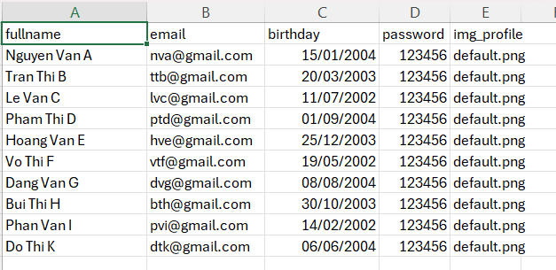
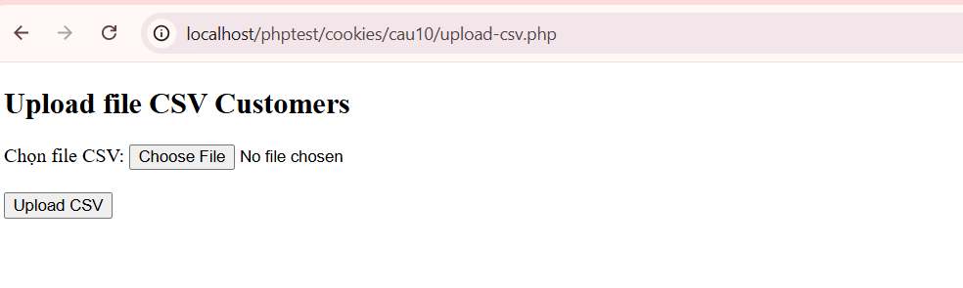
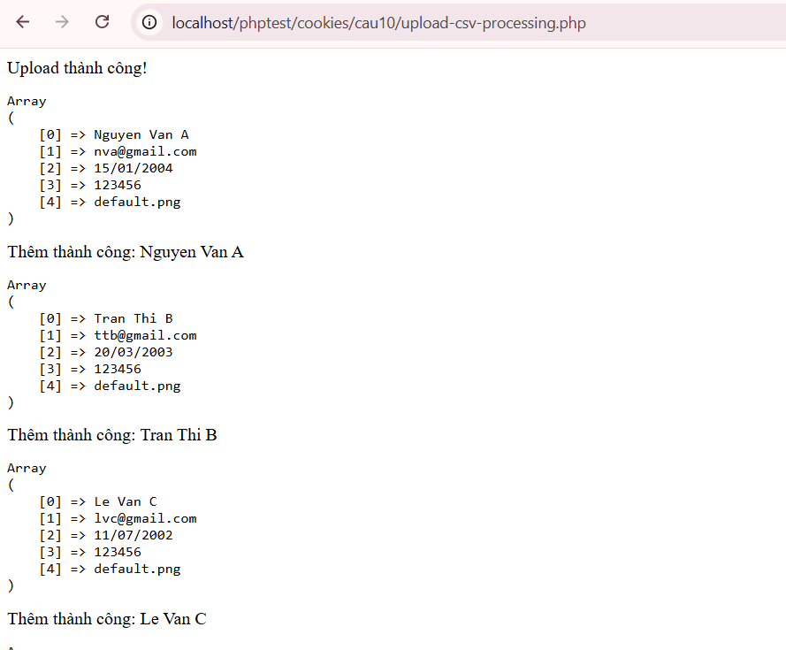

Chú ý:
- Các bạn nộp file word: Đặt tên file: <mssv><hoten><bai4>.docx nộp lên classroom, kèm với các file code đã tạo (ngoại trừ file word trả lời câu hỏi, các file còn lại các bạn nén vào file .zip).
- Mỗi câu các bạn trả lời bằng hình/trả lời dạng text tùy vào yêu cầu của câu hỏi, và ghi rõ số thứ tự câu hỏi mà bạn trả lời.
- Các bài phát hiện copy từ các bài của bạn khác sẽ không được tính điểm.
- Chú ý: Các câu trả lời có tham khảo trên Internet phải trích dẫn link

https://www.w3schools.com/sql/sql_injection.asp
https://www.w3schools.com/php/php_cookies.asp
https://www.w3schools.com/php/php_sessions.asp
https://www.w3schools.com/php/php_file_upload.asp
https://www.w3schools.com/php/func_filesystem_file.asp
https://www.php.net/manual/en/features.file-upload.post-method.php,
https://stackoverflow.com/questions/6654351/check-file-uploaded-is-in-csv-format

